Requirements Document
Group A - Team Red Panda



Peter Grypma
Chris Hobbs
Hizkia Mertadiwangsa
David Wu

Introduction

The names of our applications are Word Jumbles and Missing Letters. They are designed to work with the SynPhony Literacy System to make word based games that help a student learn to read at the level they are at. The features of these games are that they use wordlists generated by the SynPhony Literacy System to make game that only include words that contain the letters that the student has learned. The games are meant for students learning a language with varying degrees of skill and knowledge. This game provides a fun way to learn a language without the frustration of running into words with unknown letters or combinations of letters. This game is on the iOS platform for iPhone, iPad and iPod touch.

Intended Audience List
The users of this application are mainly students who are learning a new language, as well as the teachers who will assist the students when they are using this application.
The students, before they start using this application, should be starting to learn a new language, or already have some basic understandings of a few of the letters in the new language. He/she should be familiar with using an iOS based device.
The teachers who are using this application, should be familiar with the new language his/her students are learning, so that the teachers would know what to teach and how to challenge the students and correct their mistakes. The teachers also need to know how to use an iOS based device so he/she may interact with the students while using the application. Students should be able to use the application without the help of a teacher, but the teacher may assist if available.

Redo below (pg 97 headings) abt page for each one

Features/Functional Requirements
-Main menu – 3 buttons: “Play”, “Instructions” and “Settings”
-Input for selection will be from iPhone or iPad touch command
-Back button to go back to main menu
-Login screen in settings for student to sign in and pull their specific wordlist
-The student will sign in with their ID and password, which will then pull the wordlist from a specified location
-Words in game are from the student specific wordlist
-The game will select 6 random words from the pulled wordlist, making it such that the student won’t be playing a game with unknown letters
-Game screen with 6 scrambles words/ words with missing letters
-Game screen for Word Jumbles has the scrambled letters of a word with a text field beside each word. To insert guess, the user clicks the text field and types the word using the iPhone or iPad keyboard
-For missing letters, the text field is also beside the word with the missing letter, and the student types out the whole word with the missing letter included, and in this way emphasizing using the known letters in words for the student
-When all answers correct, screen with statistics is shown, such as number of incorrect guesses and a letter grade based on number of incorrect guesses
-Different languages are available depending upon the language of the student’s pulled wordlist

-Replay option at the end of the game, but each game is different since the words will be scrambled differently and the words used from the wordlist will not necessarily be the same.
-For Missing Letters, the words used will also be different game to game and the letters missing will not be the same game to game.

Non-Functional Requirements

Availability Requirements: The app will be available to play offline with the last pulled wordlist.

Reliability Requirements: Users always can synchronize their profile with the updated wordlist when the device is connected to the internet.

Security Requirements: Only users holding the role as “teacher” can update the wordlist of the users using the SynPhony system and push the wordlist to the student’s unique location

Example Tutorials

WRONG, check textbook for example, more like how to do things, more words
See posted example

Game 1 - World Jumble

The main menu screen.

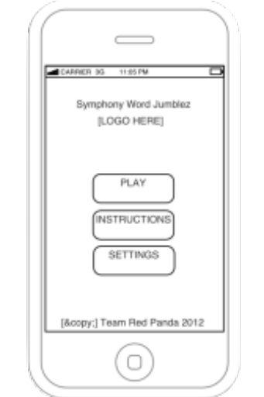(pic 1.1)
- Click Play to start the game.

It will show 6 randomly selected scrambled words from the student’s wordlist when play is selected
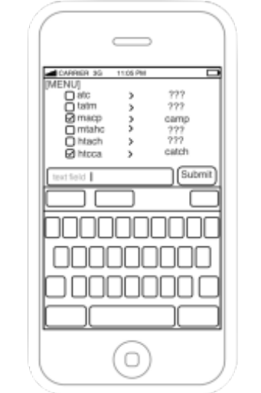(pic 1.3)
- Input the answer at the text field.
- Click on Submit or Enter
If your answer is right it will show a checkmark beside the words.

The user will have a max number of guesses, but will be at least 30 (essentially guess until answer is correct)

When the lesson is complete this screen will appear.
You will see your grade.

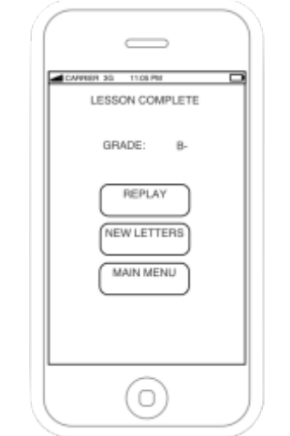(pic 1.4)
- Click Replay to try the same levels or,
- Click Main Menu to go back to main menu. (pic 1.1)

Game 2 - Missing Letters

The main menu screen.

(pic 2.1)
1. Click Play to start the game.

It will show 6 words taken from SynPhony with a random letter removed (Only 5 shown).

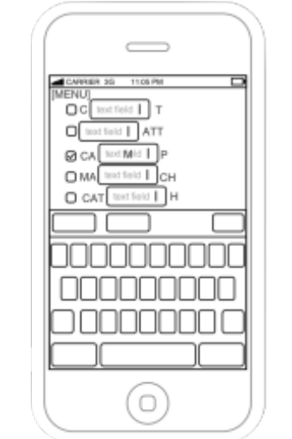(pic 2.3)
- Input the answer at the text field.
If your answer is right it will show checkmark beside the words.

When the lesson is complete this screen will appear.
You will see your grade.

(pic 2.4)
- Click Replay play game again or,
- Click Main Menu to go back to main menu. (pic 2.1)

Instruction

If users click Instructions in the Main Menu screen, it will lead to the instructions on how to play the game.

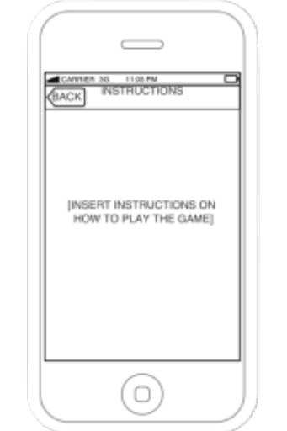(pic 3.1)

To return to the Main Menu, click the Back button.

Settings

If users click Settings in the Main Menu screen, it will lead to settings menu.

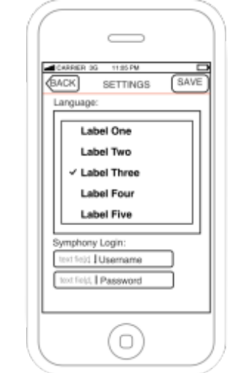(pic 4.1)
- Input Username & Password. If a new wordlist is available, it will be downloaded and used to make the words in the game

Glossary

Cancel - to make void; to delete or get rid of current selection or answer.
Grade - number of wrong guesses will correspond to letter grade ie 10 wrong guesses total corresponds to a C grade.
Instruction – information on how to play the game.
Login - the act of logging in to a database especially a multiuser computer or networked computer system.
Menu - any list or set of items.
Play - to take part or engage in a game.
Replay – start the game over, but in this case, each game will use different words.
Save - to keep from being lost.
Settings – where sign in takes place to pull wordlist, and where the user can adjust how the app will function.
Submit - to give over.

